**Cat and Dog Classifier**

Practice of Artificial Intelegence

Name : 劉泰佑

Id : C100E030

1. Data training 15 times

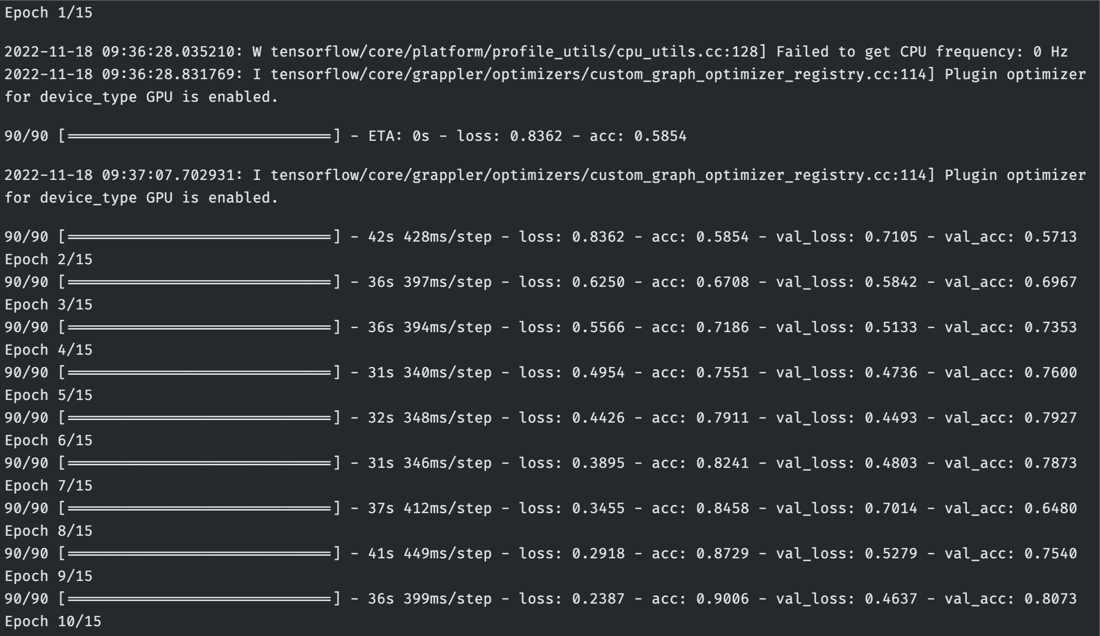

1. Validation and Training Accuracy

1. Validation and Training Loss

1. Score

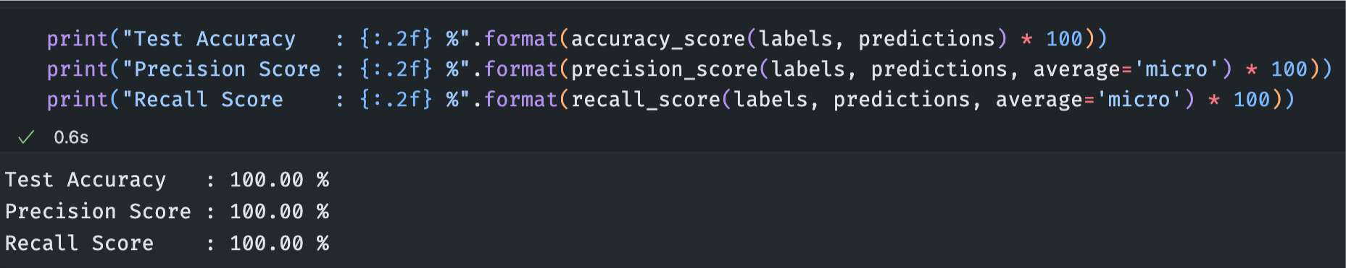

1. Confusion Matrix

1. Testing (because I use VSCode, so I have to modify the image test section)

